WRITE UP LKS 2025

SMKN 1 CILACAP

Cryptography

1.101010101

Flag = lks_smk{53m0g4_4nd4_m3nj4d1_JU4RA}

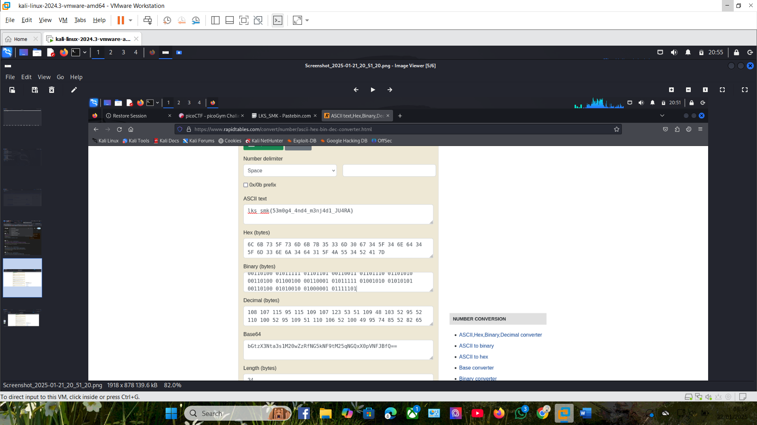

GIT SC

1.Kembalikan Source Codeku

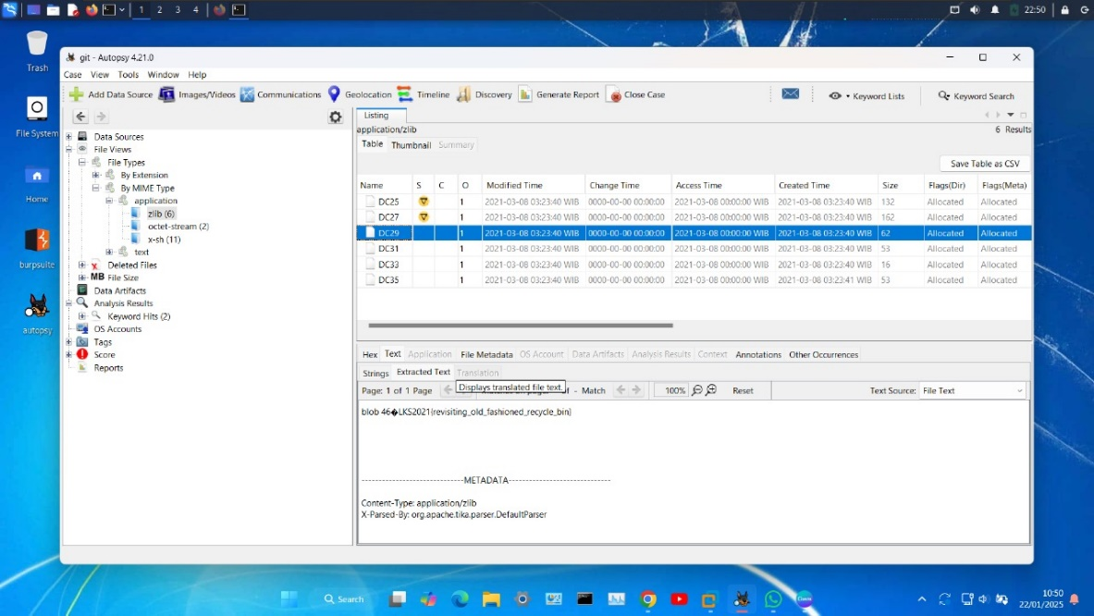flag = LKS2021{revisiting_old_fashioned_recycle_bin}

Web Exploit

1.Login CCTV

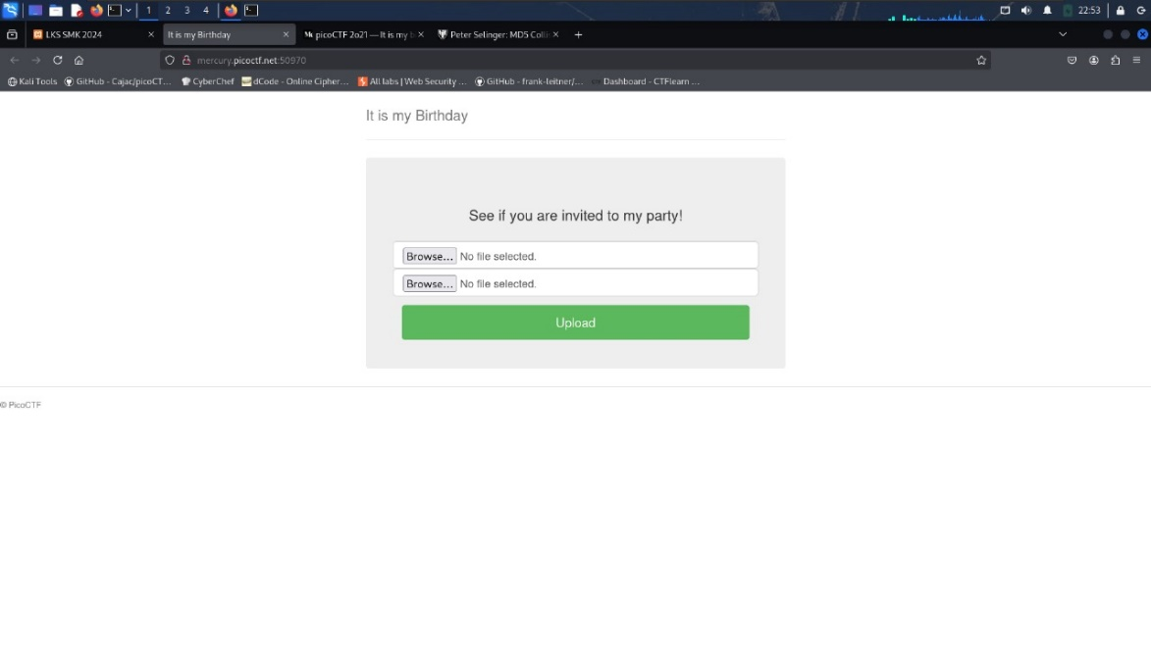flag = picoCTF{c0ngr4ts_u_r1nvit3d_73b0c8ad}

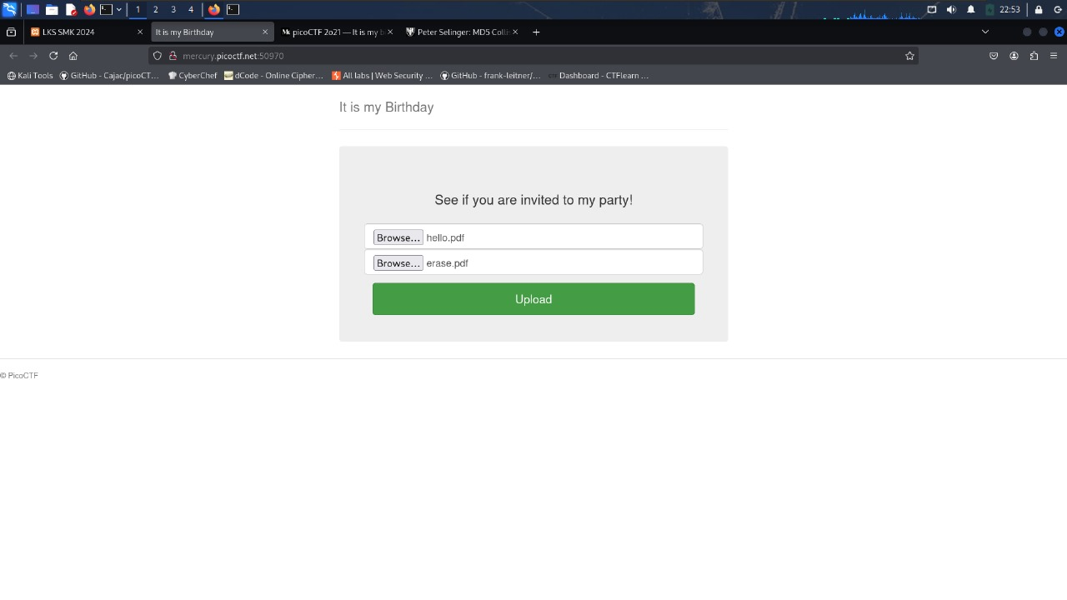

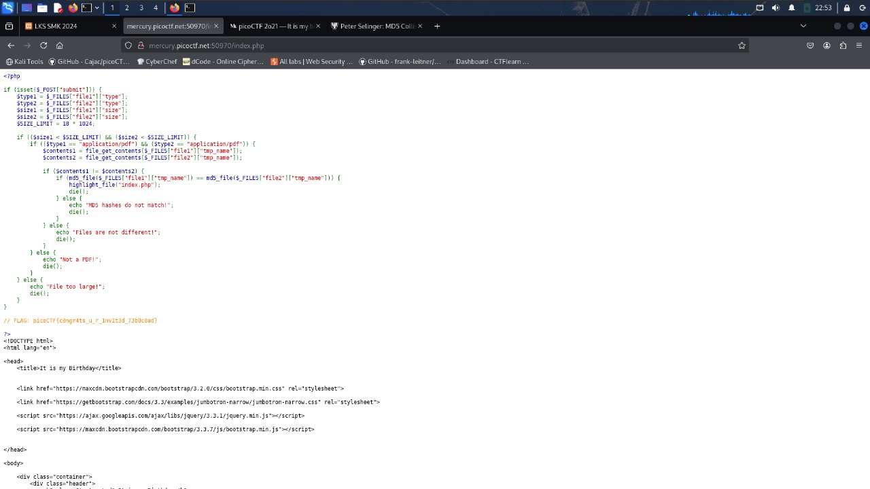

Forensic

1.Investigasi File Rahasia

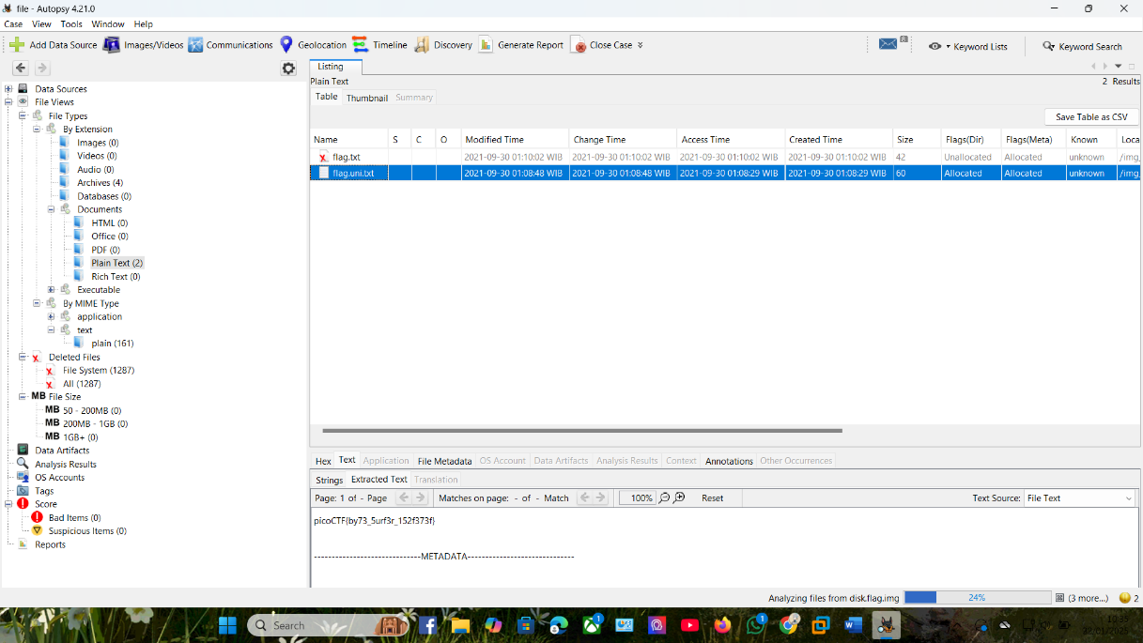Flag = picoCTF{by73_5urf3r_152f373f}

2.Network Forensic

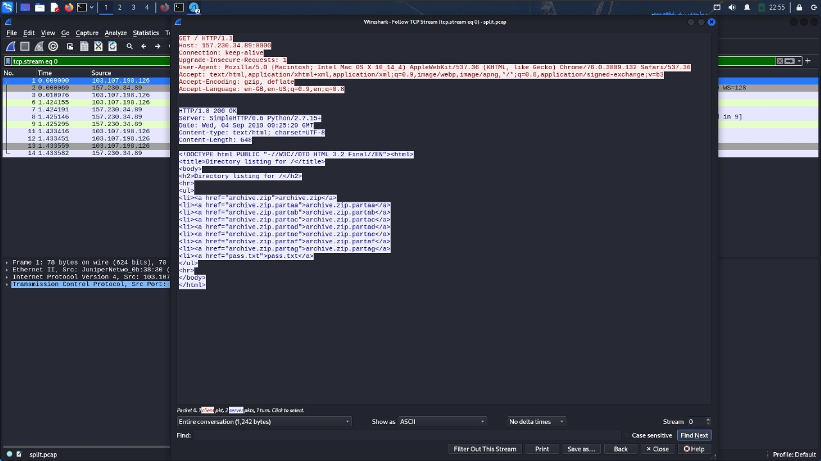 Flag = CJ2019{34675bfac354ea00d7e9ce1ae51ac880d03a0308}

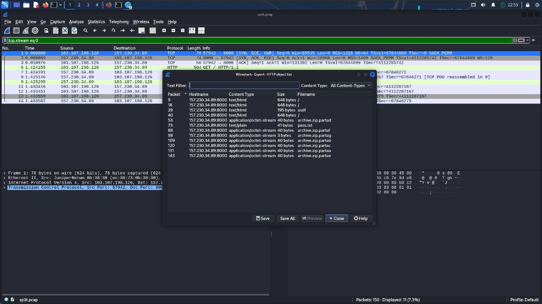

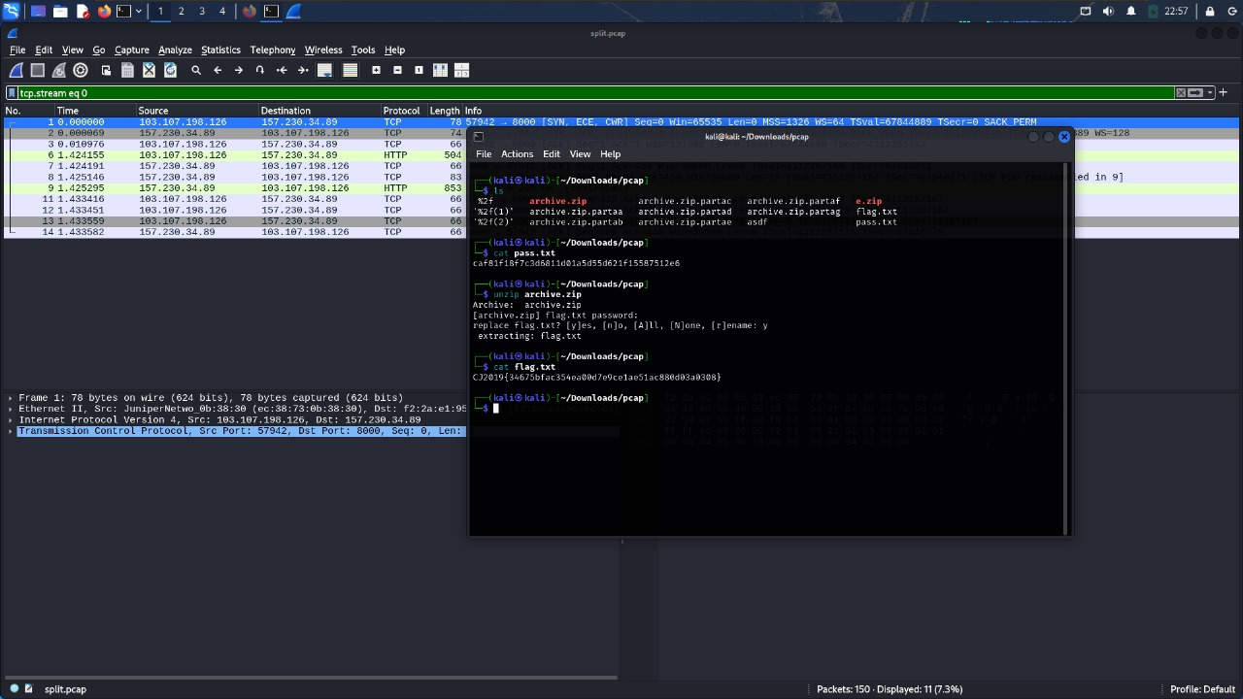

APK

1.Bongkar apk

Flag = FLAG{57ERL1NG_4RCH3R}

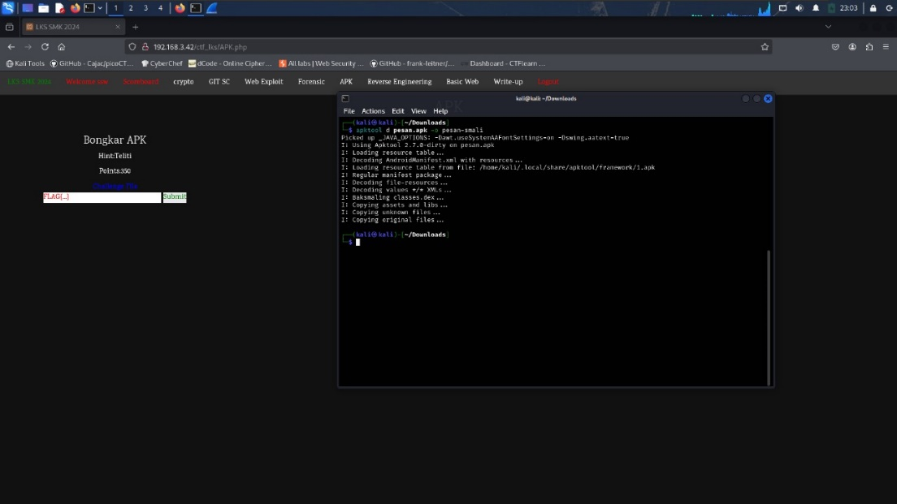

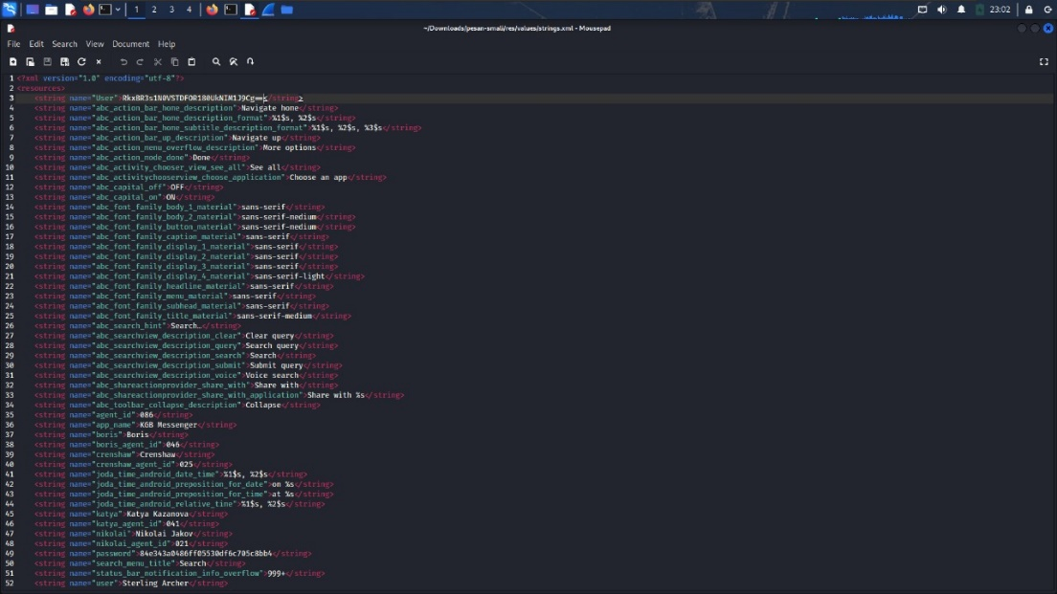

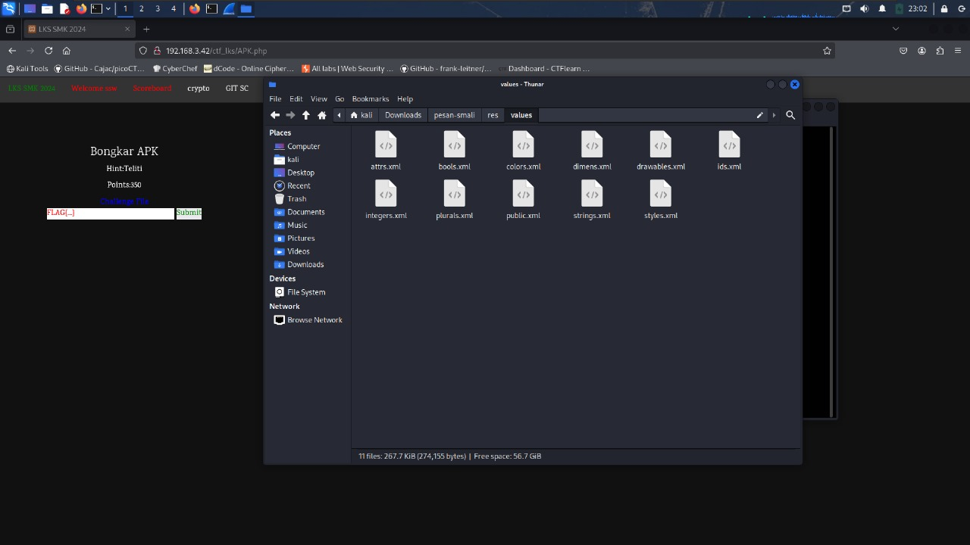

Reverse Engineering

1 Jalankan Program berikut, apa yang terjadi

Flag = picoCTF{U51N6_Y0Ur_F1r57_F113_e5559d46}

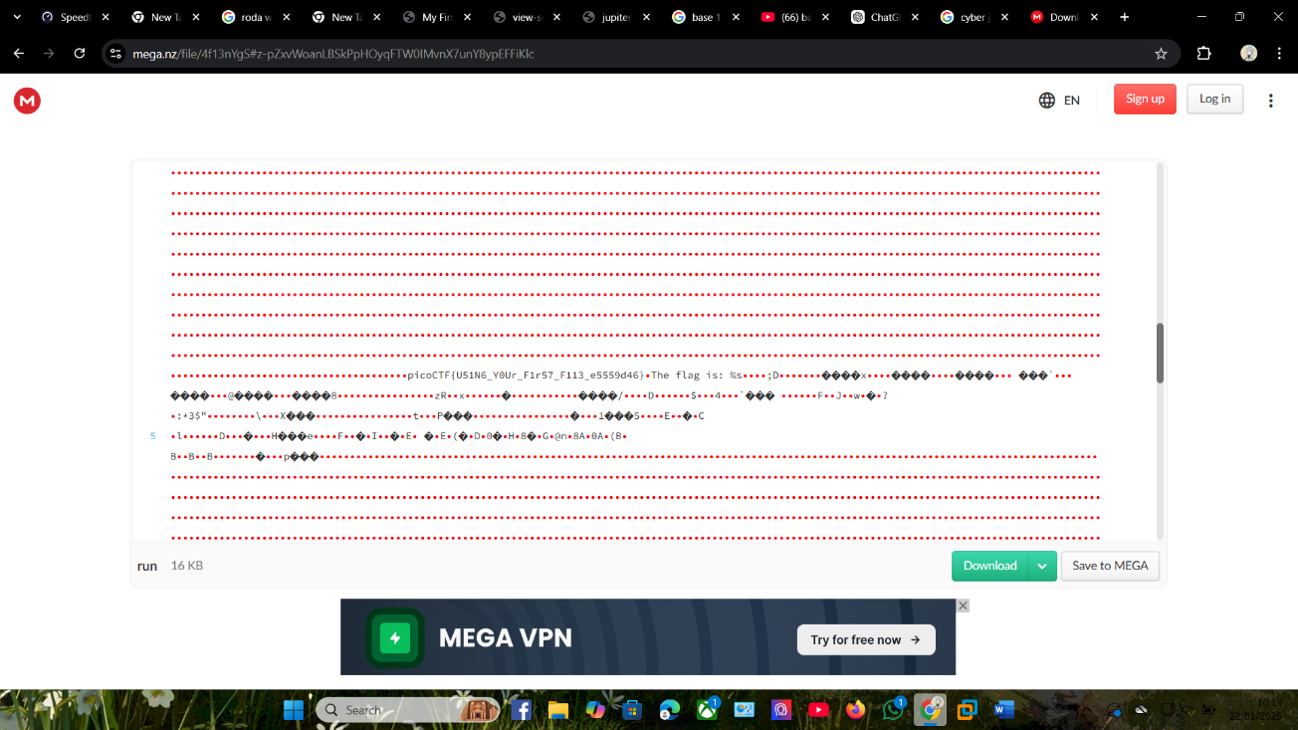

Basic Web

1 link Berikut butuh diperiksa tools

Flag= picoCTF{tru3_d3t3ct1ve_0r_ju5t_lucky?f10be399}

